Bellringer – Monday 09/19/16
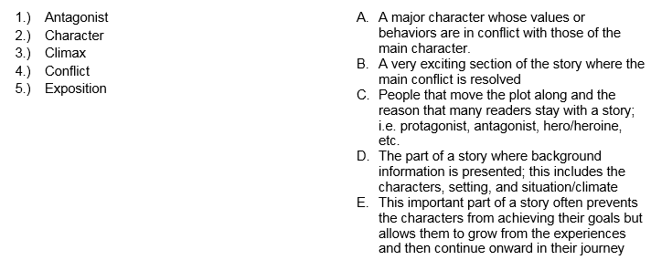
Bellringer – Monday 09/19/16

Bellringer – Monday 09/19/16

